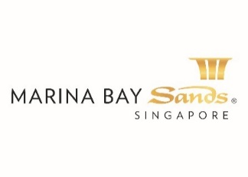 | FASCIA NAME FORM - 2024  E-mail to:  MARINA BAY SANDS PTE LTD – ATTN: SANDS EXPO & CONVENTION CENTRE – CUSTOMER SERVICE CENTRE  10 BAYFRONT AVENUE SINGAPORE 018956  P: +65 6688 3888 F: +65 6688 3889 E: secc@marinabaysands.com
EVENT NAME: APATS 2024 (50977) |  |  | EVENT DATES: 9 – 11 September 2024 |  | BOOTH # / MTG. ROOM #
EXHIBITING CO. NAME: |  |  | HALL LOCATION: Level 3 Hibiscus & Jasmine Main Ballrooms
STREET ADDRESS: |  | CITY: |  | STATE: | ZIP CODE:
TELEPHONE: |  | FAX: |  | E-MAIL:
ORDERED BY: (DR/HON/PROF/MDM/MISS/MRS/MS/MR)  (Print Name) |  | JOB TITLE: |  | SIGNATURE:

Name of company as it should appeared on fascia board. Maximum length 30 Letters.

Only one fascia name is allowed on each exhibiting stand unless approved by the Organizer. All Organizers’ Walk on Stands will be provided with 3 walls and one open front.
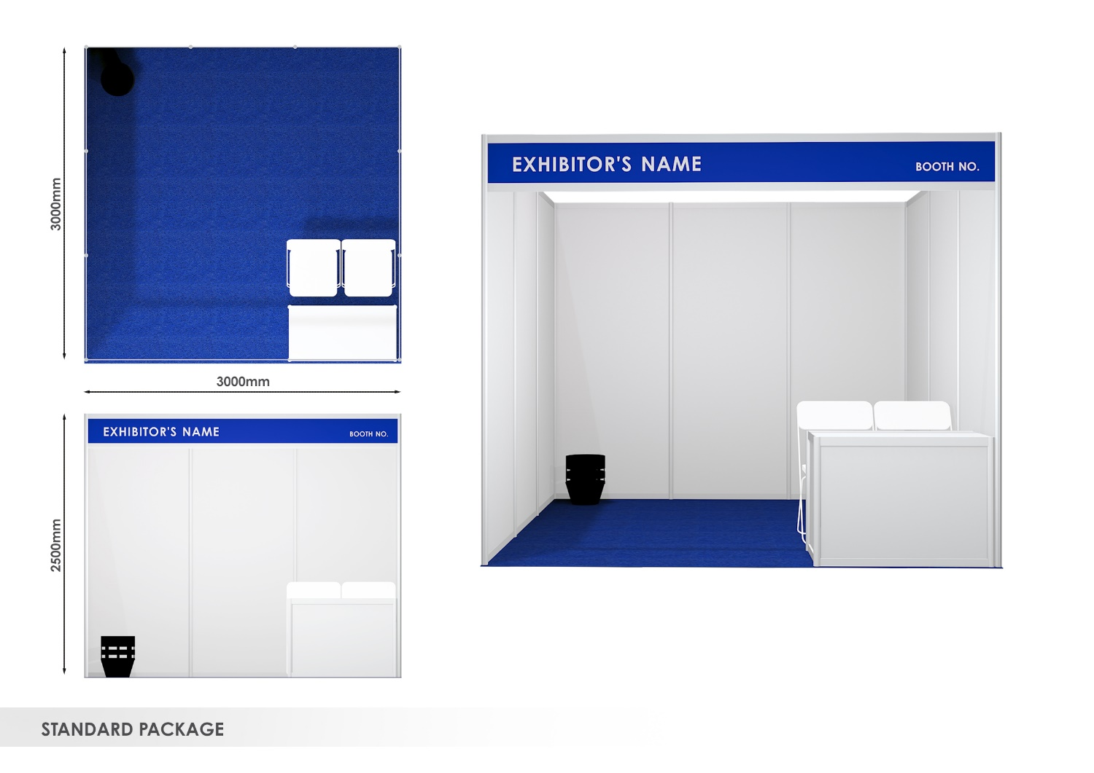

IMPORTANT:
This form must be received No later than 29 JULY 2024

  - Please Keep A Copy For Your Records –

Prices, Policies, and Procedures Subject to Change without prior notice.

GST Registration No. M90364464C

